**BÁO CÁO THÍ NGHIỆM**

**IT3103 – 750864 – LẬP TRÌNH HƯỚNG ĐỐI TƯỢNG (TN)**

**Lab 1: Environment Setup and Java Basics**

|  |  |
| --- | --- |
| Họ và tên | Trần Đức Nam Anh |
| Mã số sinh viên | 20235655 |

**GitHub repository**: OOP.Lab.20242.750864.20235655.TranDucNamAnh (không công khai)

**Phần 2.2**:

2.2.1. Code:

Kết quả chạy:

2.2.2. Code:

Kết quả: Hiện ra 1 hộp thoại như sau:

2.2.3 Code:

2.2.4. Code:

Nhập 2 số 10000 và 68.686 ta được:

2.2.5. Code:

VD: Khi nhập vào 2 số 10 và -5 ta được

(Tổng, Hiệu, Tích, Thương của 10 và -5)

( Không thể chia cho 0)

2.2.6. Code:

VD1: Giải phương trình 4x + 3 = 0

VD2: Giải hệ

1. 3x + 2y = 10
2. x – y = 0.5

VD3: Giải phương trình x^2 + 3x + 2 = 0

6.1. Code:

Kết quả chạy: Hiện ra hộp thoại

Nếu người dùng chọn Cancel, kết quả chạy:

Để tuỳ chỉnh nội dung và các lựa chọn trong hộp thoại ta có thể làm theo đoạn code sau:

6.2. Code:

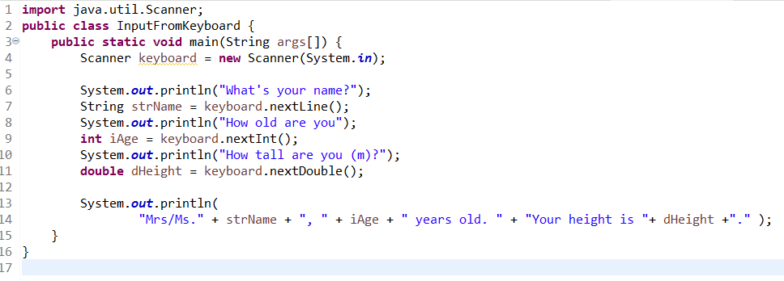

Kết quả chạy (terminal):

6.3. Code:

VD: Chiều cao = 35

6.4. Code:

Một số ví dụ:

6.5. Code

Ví dụ:

6.6. Code:

Ví dụ:

